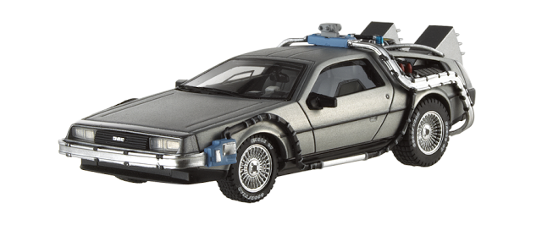
The Future of Transportation

Objective: Identify and research alternative forms of transportation. Share and discuss research of possible future technologies with classmates.
Directions: Choose a form of transportation that is currently being developed, tested, or imagined for future use. Research your chosen form of transportation and take notes about important information related to the vehicle and its infrastructure. Create a presentation to share your information with your classmates.
Information to Include:
- What is the name of your new transportation technology?

- Give a brief description of your technology.

- What is the vehicle designed to move or transport?

- How does this new form of transportation work? (Or how is it supposed to work?)

- What is used to power or fuel this vehicle?

- What kind of infrastructure is necessary to support this new technology?

- What are the advantages of the new technology over current methods of transportation?

- What are some possible disadvantages of this technology?

- What are the projected costs associated with the vehicle and infrastructure?

- The year is 2050, the people of Plymouth are considering new alternative forms of transportation. The transportation technology that you researched is one option that is available to the people. Should the people of Plymouth choose your technology? Why or why not?

